**Date Filters**

**1. Out of all the products shipped in year 2010 which was the largest selling products (in terms of sales)?**

**Ans : - BretfordCR8500SeriesMeetingRoom Furniture**

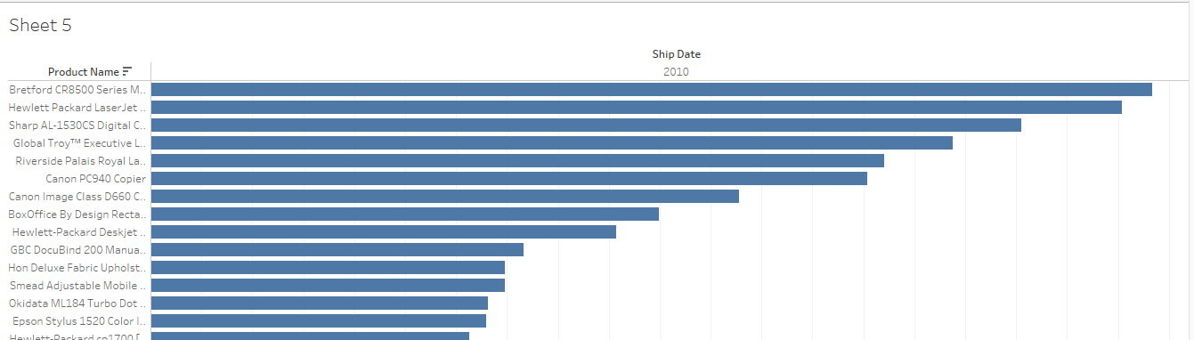

**2. Of all the products shipped in June 2009 which had the highest quality ? Ans : - Avery494**

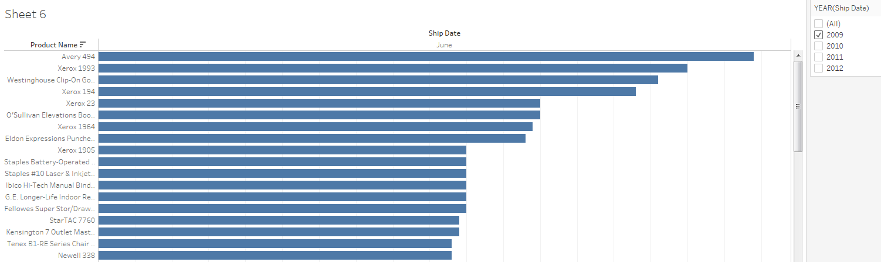

**3. As per the order datewhat was the total generated by Product Category =”Office Supplies” Between 1st August 2010 to August 2012 ?**

**Ans : - 241,005**

